**Assignment Attachment**

* **DDL SCRIPT FILE TO CREATE THE TABLE**



* **INSERT SCRIPT FOR SAMPLE DUMP**





* **SQL SCRIPTS SELECT OPERATIONS IN DATABASE**



* **All files in the zip - **

**Output Screenshots -**

* **BOOK_TABLE -**

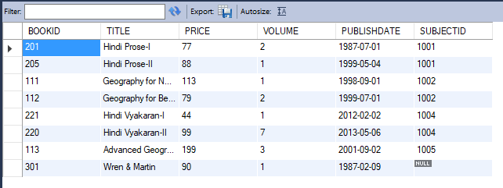

* **SUBJECT_TABLE -**

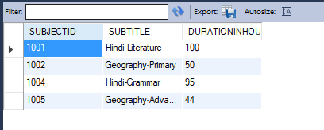

**SELECT * FROM SUBJECT_TABLE S, BOOK_TABLE B WHERE B.SUBJECTID = S.SUBJECTID ORDER BY S.SUBJECTID ASC;**

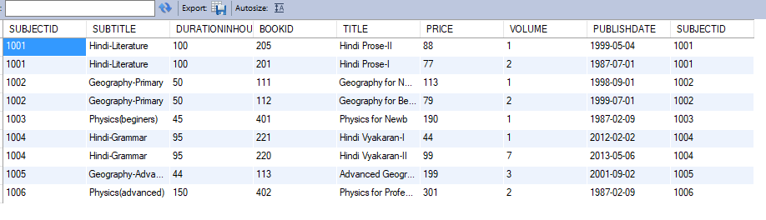

**SELECT * FROM BOOK_TABLE ORDER BY PUBLISHDATE ASC;**

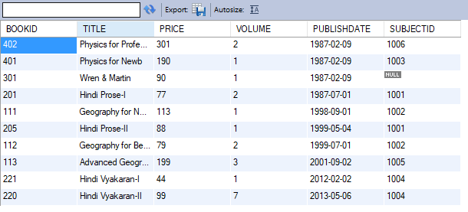

**SELECT * FROM BOOK_TABLE WHERE DATE(PUBLISHDATE) BETWEEN STR_TO_DATE('1998-09-01','%Y-%m-%d') AND STR_TO_DATE('2012-02-02','%Y-%m-%d');**

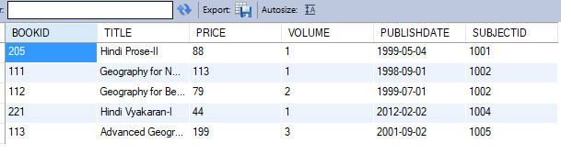

**SELECT S.SUBJECTID, S.SUBTITLE, COUNT(*) AS "NUMBER_OF_BOOKS"**

**FROM SUBJECT_TABLE S, BOOK_TABLE B**

**WHERE B.SUBJECTID = S.SUBJECTID**

**GROUP BY S.SUBJECTID**

**HAVING S.SUBTITLE LIKE 'H%' OR S.SUBTITLE LIKE 'G%';**

